# ALU UVM DESIGN REQUIRMENTS PDF

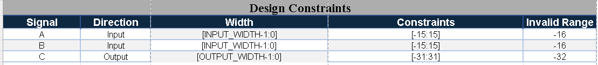

# ALU UVM DESIGN REQUIRMENTS PDF

# ALU UVM DESIGN REQUIRMENTS PDF

